**Computer System**

A computer system can be divided roughly into four components: the hardware, the operating system, the application programs, and the users.

The hardware—the central processing unit (CPU), the memory, and the input/output (I/O) devices provides the basic computing resources for the system.

The application programs—such as word processors, spreadsheets, compilers, and Web browsers—define the ways in which these resources are used to solve users’ computing problems.

The operating system— controls the hardware and coordinates its use among the various application programs for the various users

Users— People, machines, other computers.

We can also view a computer system as consisting of hardware, software, and data. The operating system provides the means for proper use of these resources in the operation of the computer system. An operating system is similar to a government. Like a government, it performs no useful function by itself. It simply provides an environment within which other programs can do useful work.

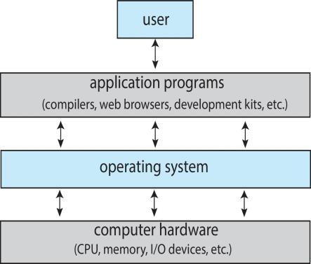

Figure 1.1 Abstract view of the components of a computer system.

**What Operating Systems Do**

We begin our discussion by looking at the operating system’s role in the overall computer system. A computer system can be divided roughly into four components: the hardware, the operating system, the application programs, and the users (Figure 1.1). The hardware—the central processing unit (CPU), the memory, and the input/output (I/O) devices—provides the basic computing resources for the system. The application programs—such as word processors, spreadsheets, compilers, and Web browsers—define the ways in which these resources are used to solve users’ computing problems. The operating system controls the hardware and coordinates its use among the various application programs for the various users. We can also view a computer system as consisting of hardware, software, and data. The operating system provides the means for proper use of these resources in the operation of the computer system. An operating system is similar to a government. Like a government, it performs no useful function by itself. It simply provides an environment within which other programs can do useful work. To understand more fully the operating system’s role, we next explore operating systems from two viewpoints: that of the user and that of the system.

**User View**

The user’s view of the computer varies according to the interface being used. Most computer users sit in front of a PC, consisting of a monitor, keyboard, mouse, and system unit. Such a system is designed for one user to monopolize its resources. The goal is to maximize the work (or play) that the user is performing. In this case, the operating system is designed mostly for ease of use, with some attention paid to performance and none paid to resource utilization—how various hardware and software resources are shared. Performance is, of course, important to the user; but such systems are optimized for the single-user experience rather than the requirements of multiple users.

In other cases, a user sits at a terminal connected to a mainframe or a minicomputer. Other users are accessing the same computer through other terminals. These users share resources and may exchange information. The operating system in such cases is designed to maximize resource utilization— to assure that all available CPU time, memory, and I/O are used efficiently and that no individual user takes more than her fair share.

In still other cases, users sit at workstations connected to networks of other workstations and servers. These users have dedicated resources at their disposal, but they also share resources such as networking and servers, including file, compute, and print servers. Therefore, their operating system is designed to compromise between individual usability and resource utilization.

Recently, many varieties of mobile computers, such as smartphones and tablets, have come into fashion. Most mobile computers are standalone units for individual users. Quite often, they are connected to networks through cellular or other wireless technologies. Increasingly, these mobile devices are replacing desktop and laptop computers for people who are primarily interested in using computers for e-mail and web browsing. The user interface for mobile computers generally features a touch screen, where the user interacts with the system by pressing and swiping fingers across the screen rather than using a physical keyboard and mouse.

Some computers have little or no user view. For example, embedded computers in home devices and automobiles may have numeric keypads and may turn indicator lights on or off to show status, but they and their operating systems are designed primarily to run without user intervention.

**System View**

From the computer’s point of view, the operating system is the program most intimately involved with the hardware. In this context, we can view an operating system as a resource allocator. A computer system has many resources that may be required to solve a problem: CPU time, memory space, file-storage space, I/O devices, and so on. The operating system acts as the manager of these resources. Facing numerous and possibly conflicting requests for resources, the operating system must decide how to allocate them to specific programs and users so that it can operate the computer system efficiently and fairly. As we have seen, resource allocation is especially important where many users access the same mainframe or minicomputer.

A slightly different view of an operating system emphasizes the need to control the various I/O devices and user programs. An operating system is a control program. A control program manages the execution of user programs to prevent errors and improper use of the computer. It is especially concerned with the operation and control of I/O devices.

**Defining Operating Systems**

By now, you can probably see that the term operating system covers many roles and functions. That is the case, at least in part, because of the myriad designs and uses of computers. Computers are present within toasters, cars, ships, spacecraft, homes, and businesses. They are the basis for game machines, music players, cable TV tuners, and industrial control systems. Although computers have a relatively short history, they have evolved rapidly. Computing started as an experiment to determine what could be done and quickly moved to fixed-purpose systems for military uses, such as code breaking and trajectory plotting, and governmental uses, such as census calculation. Those early computers evolved into general-purpose, multifunction mainframes, and that’s when operating systems were born. In the 1960s, Moore’s Law predicted that the number of transistors on an integrated circuit would double every eighteen months, and that prediction has held true. Computers gained in functionality and shrunk in size, leading to a vast number of uses and a vast number and variety of operating systems.

How, then, can we define what an operating system is? In general, we have no completely adequate definition of an operating system. Operating systems exist because they offer a reasonable way to solve the problem of creating a usable computing system. The fundamental goal of computer systems is to execute user programs and to make solving user problems easier. Computer hardware is constructed toward this goal. Since bare hardware alone is not particularly easy to use, application programs are developed. These programs require certain common operations, such as those controlling the I/O devices. The common functions of controlling and allocating resources are then brought together into one piece of software: the operating system.

In addition, we have no universally accepted definition of what is part of the operating system. A simple viewpoint is that it includes everything a vendor ships when you order “the operating system.” The features included, however, vary greatly across systems. Some systems take up less than a megabyte of space and lack even a full-screen editor, whereas others require gigabytes of space and are based entirely on graphical windowing systems. A more common definition, and the one that we usually follow, is that the operating system is the one program running at all times on the computer—usually called the kernel. (Along with the kernel, there are two other types of programs: system programs, which are associated with the operating system but are not necessarily part of the kernel, and application programs, which include all programs not associated with the operation of the system.)

The matter of what constitutes an operating system became increasingly important as personal computers became more widespread and operating systems grew increasingly sophisticated. In 1998, the United States Department of Justice filed suit against Microsoft, in essence claiming that Microsoft included too much functionality in its operating systems and thus prevented application vendors from competing. (For example, a Web browser was an integral part of the operating systems.) As a result, Microsoft was found guilty of using its operating-system monopoly to limit competition.

Today, however, if we look at operating systems for mobile devices, we see that once again the number of features constituting the operating system is increasing. Mobile operating systems often include not only a core kernel but also middleware—a set of software frameworks that provide additional services to application developers. For example, each of the two most prominent mobile operating systems—Apple’s iOS and Google’s Android—features a core kernel along with middleware that supports databases, multimedia, and graphics (to name a only few).

**Computer System Organization**

In this section, we look at several parts of this structure. The section is mostly concerned with computer-system organization, so you can skim or skip it if you already understand the concepts.

**Computer-System Operation**

A modern general-purpose computer system consists of one or more CPUs and a number of device controllers connected through a common bus that provides access to shared memory (Figure 1.2). Each device controller is in charge of a specific type of device (for example, disk drives, audio devices, or video displays). The CPU and the device controllers can execute in parallel, competing for memory cycles. To ensure orderly access to the shared memory, a memory controller synchronizes access to the memory.

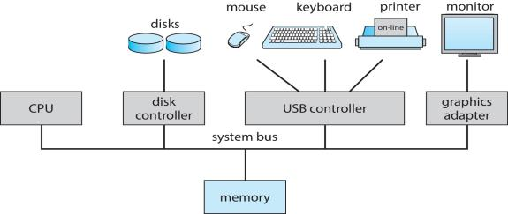

Figure 1.2 A modern computer system.

For a computer to start running—for instance, when it is powered up or rebooted—it needs to have an initial program to run. This initial program, or bootstrap program, tends to be simple. Typically, it is stored within the computer hardware in read-only memory (ROM) or electrically erasable programmable read-only memory (EEPROM), known by the general term firmware. It initializes all aspects of the system, from CPU registers to device controllers to memory contents. The bootstrap program must know how to load the operating system and how to start executing that system. To accomplish this goal, the bootstrap program must locate the operating-system kernel and load it into memory.

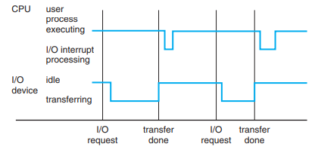

Figure 1.3 Interrupt timeline for a single process doing output.

Once the kernel is loaded and executing, it can start providing services to the system and its users. Some services are provided outside of the kernel, by system programs that are loaded into memory at boot time to become system processes, or system daemons that run the entire time the kernel is running. On UNIX, the first system process is “init,” and it starts many other daemons. Once this phase is complete, the system is fully booted, and the system waits for some event to occur.

The occurrence of an event is usually signaled by an interrupt from either the hardware or the software. Hardware may trigger an interrupt at any time by sending a signal to the CPU, usually by way of the system bus. Software may trigger an interrupt by executing a special operation called a system call (also called a monitor call).

When the CPU is interrupted, it stops what it is doing and immediately transfers execution to a fixed location. The fixed location usually contains the starting address where the service routine for the interrupt is located. The interrupt service routine executes; on completion, the CPU resumes the interrupted computation. A timeline of this operation is shown in Figure 1.3.

Interrupts are an important part of a computer architecture. Each computer design has its own interrupt mechanism, but several functions are common. The interrupt must transfer control to the appropriate interrupt service routine. The straightforward method for handling this transfer would be to invoke a generic routine to examine the interrupt information. The routine, in turn, would call the interrupt-specific handler. However, interrupts must be handled quickly. Since only a predefined number of interrupts is possible, a table of pointers to interrupt routines can be used instead to provide the necessary speed. The interrupt routine is called indirectly through the table, with no intermediate routine needed. Generally, the table of pointers is stored in low memory (the first hundred or so locations). These locations hold the addresses of the interrupt service routines for the various devices. This array, or interrupt vector, of addresses is then indexed by a unique device number, given with the interrupt request, to provide the address of the interrupt service routine for the interrupting device. Operating systems as different as Windows and UNIX dispatch interrupts in this manner.

The interrupt architecture must also save the address of the interrupted instruction. Many old designs simply stored the interrupt address in a fixed location or in a location indexed by the device number. More recent architectures store the return address on the system stack. If the interrupt routine needs to modify the processor state—for instance, by modifying register values—it must explicitly save the current state and then restore that state before returning. After the interrupt is serviced, the saved return address is loaded into the program counter, and the interrupted computation resumes as though the interrupt had not occurred.